
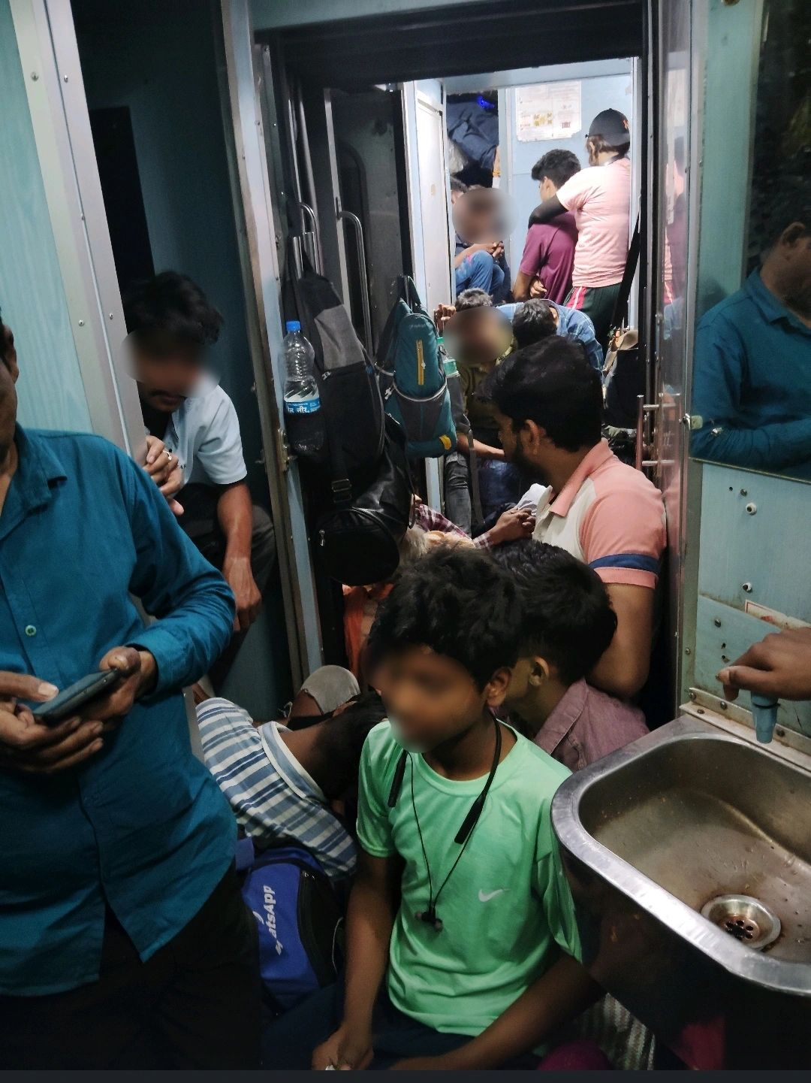

"We're solving for India"

I hear this line more than I'd like to.

From bigshot VCs at conferences to hustlers in Bengaluru.

I overheard this line every third conversation when we were just wrapping up a SBCC project about vaccines, giving our presentation in a centralised AC enabled conference room at a 5 star hotel.

I heard the same line by every young entrepreneur when we wrapped our event at IIT Delhi about "creating better people, products and society using beSci".

Something always feels off about it.

Because the very next day I boarded a train with a general ticket right before a festival from Delhi to Varanasi.

There I had my India in front of me.

I stood at the same spot for 8 hours just looking at how we were - simply existing.

And thinking what does solving for "India" really mean?

Then a few people pop up saying but Utkarsh solving for "India" and "Bharat" are different no?

Right, and terribly wrong at the same time.

I've been part of the "Bharat" and the "India" both.

I've slept on railway platforms with just a bedsheet along with my father who himself is a railway employee when trains were delayed. We were Bharat and India at the same time.

I've travelled without tickets when going somewhere was really important and there's no chance you're getting a seat unless you book your ticket at least a month in advance.

I've been woken up at 3 a.m by my coaches to figure out a tatkal ticket for my teams even when the counter opens up much later.

All of us are as much "Bharat" as we are "India".

And this is especially true when you're trying to "solve" for it.

Making money from it is a different story.

But having that awareness will do all of us good.

India 1, 2, and 3 exist.

User personas exist.

Cultural differences exist.

And all of them interact with each other all the time, all of that is part of the same system.

We can always figure out how to game one part of the system to our advantage - but do not confuse it with solving for it.

India does not exist in Silos.

India is an emergent system of multiple complex systems. Not merely a TG.

